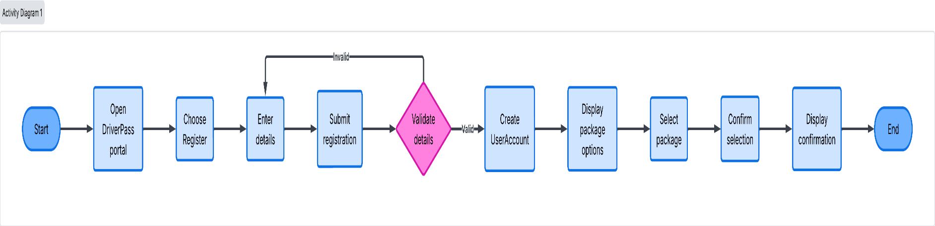

- This diagram illustrates the high-level functional boundaries of the DriverPass system. It outlines the core actors, including Customers, Secretaries, IT Officers, the Owner (Liam), and the external DMV system—and maps them to their respective primary use cases, such as account registration, package selection, lesson scheduling, and policy access.

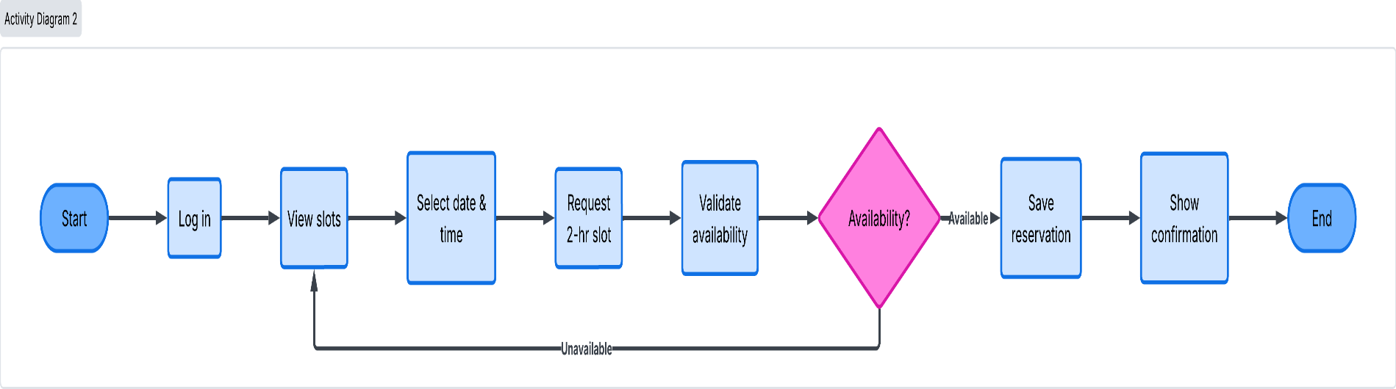

- This workflow details the step-by-step process a user follows to register within the DriverPass platform. It outlines the path from opening the portal and entering details, through the system's data validation check, up to account creation and package selection.

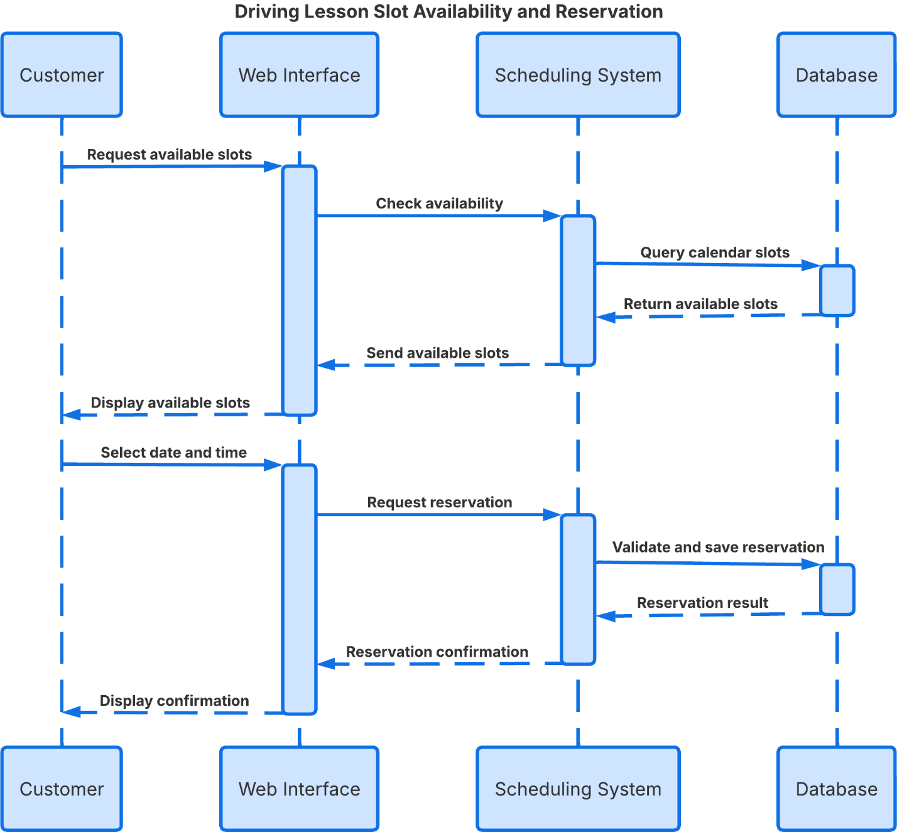

- This workflow maps out the logic for booking a 2-hour driving lesson slot. It includes conditional validation to check real-time schedule availability, handling loops for unavailable time slots to ensure double bookings are avoided before saving the final confirmation.
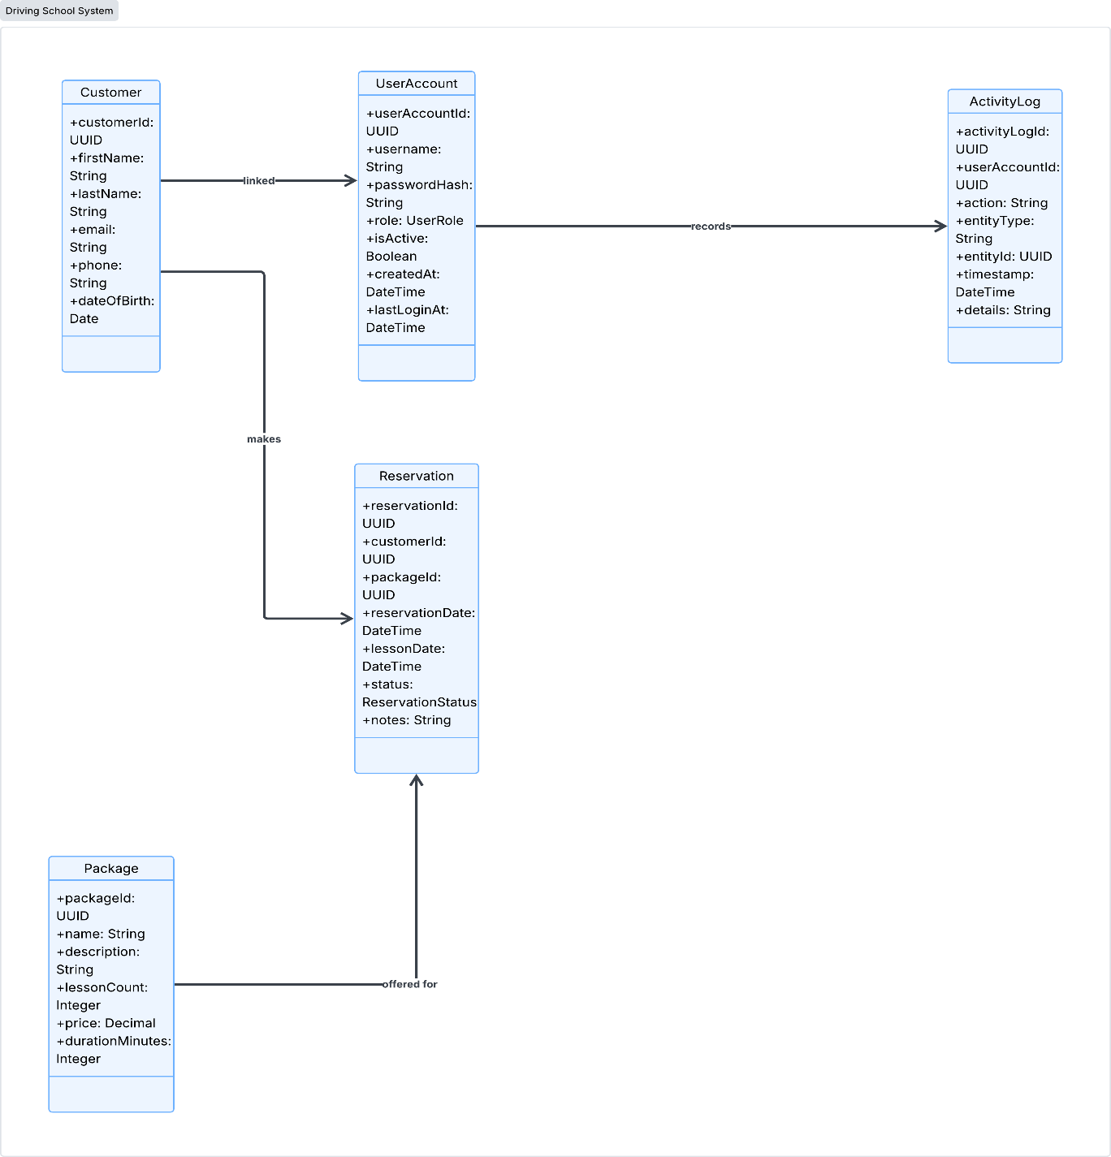

- This diagram demonstrates the chronological message passing between system components during a scheduling session. It highlights how the Customer, Web Interface, Scheduling System, and Database interact dynamically to query calendar slots, validate availability, and return reservation results.

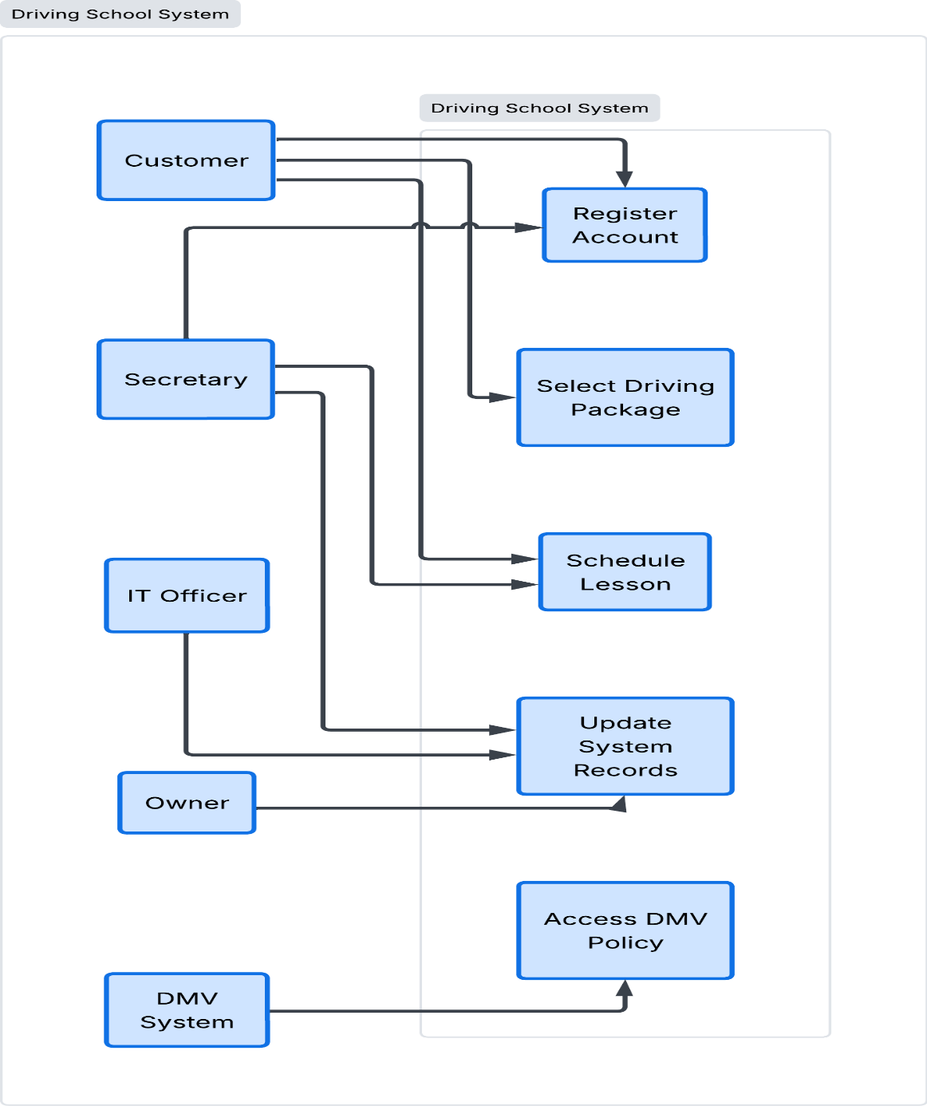

- This structural diagram defines the core object-oriented classes utilized within the backend architecture: Customer, UserAccount, ActivityLog, Reservation, and Package. It highlights their key attributes (such as UUIDs, timestamps, and parameters) and establishes their relational links.
Technical Requirements

- Hosting Environment: The system operates as a cloud-based web application, eliminating the need for local physical server maintenance and ensuring accessibility across devices.

- Software Architecture: Built on a modular multi-tier design separating the user interface, scheduling logic, and database layer for streamlined performance and future scalability.

- Security & Compliance: Implements role-based access control (RBAC) to restrict administrative functions, alongside immutable activity logging to track all account updates, administrative actions, and reservation modifications.

